Harini G
192524011

EXPERIMENT 1
Analysis, Development and Verification of 8-bit and 16-bit Arithmetic Operations Using Assembly Language Program
A. 8-Bit Addition and Subtraction
Aim
To perform 8-bit addition and subtraction using the 8085 microprocessor. To store the sum, difference, carry, borrow and flag values in memory.
Apparatus Required
- 8085 Microprocessor Simulator / Trainer Kit
- Keyboard
- Power Cord
Procedure
- Enter the program starting at memory address 4100.
- Store the first input 9C at 4500 and the second input 7A at 4501.
- Execute the program using the GO/EXEC command.
- Perform addition and store the sum, carry and flag values at 4502, 4503 and 4504.
- Perform subtraction and store the difference, borrow and flag values at 4505, 4506 and 4507.
- Examine the memory locations and verify the results.
Pseudocode
START
Load the first number
Load the second number
Add both numbers
Store sum and carry
Store flags after addition
Subtract the second number
Store difference and borrow
Store flags after subtraction
STOP
Input
Address | Data
4500 | 9C
4501 | 7A
Output
Address | Output | Description
4502 | 16 | Sum
4503 | 01 | Carry
4504 | 11 | Flags after addition
4505 | 22 | Difference
4506 | 00 | Borrow
4507 | 14 | Flags after subtraction
Result
The 8-bit addition and subtraction operations were executed successfully. The sum, difference, carry, borrow and flag values were verified.

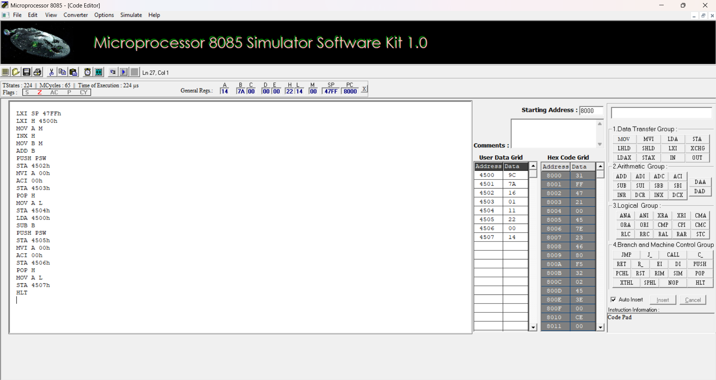

B. 16-Bit Addition and Subtraction
Aim
To perform 16-bit addition and subtraction using the 8085 microprocessor. To store the sum, difference, carry and borrow in memory.
Apparatus Required
- 8085 Microprocessor Simulator / Trainer Kit
- Keyboard
- Power Cord
Procedure
- Enter the program starting at memory address 4200.
- Store the first number 1234 from address 4510 and the second number 5678 from address 4512, with the lower byte first.
- Execute the program using the GO/EXEC command.
- Add the two 16-bit numbers and store the sum at 4514 and 4515, with carry at 4516.
- Subtract the second number from the first number.
- Store the difference at 4518 and 4519, with borrow at 451A.
- Examine the memory locations and verify the results.
Pseudocode
START
Load the first 16-bit number
Load the second 16-bit number
Add both numbers
Store sum and carry
Subtract the second number from the first
Store difference and borrow
STOP

Input
Address | Data
4510 | 34
4511 | 12
4512 | 78
4513 | 56
Output
Address | Output | Description
4514 | AC | Sum – lower byte
4515 | 68 | Sum – upper byte
4516 | 00 | Carry
4518 | BC | Difference – lower byte
4519 | BB | Difference – upper byte
451A | 01 | Borrow
Result
The 16-bit addition and subtraction operations were executed successfully.
The sum, difference, carry and borrow values were verified.
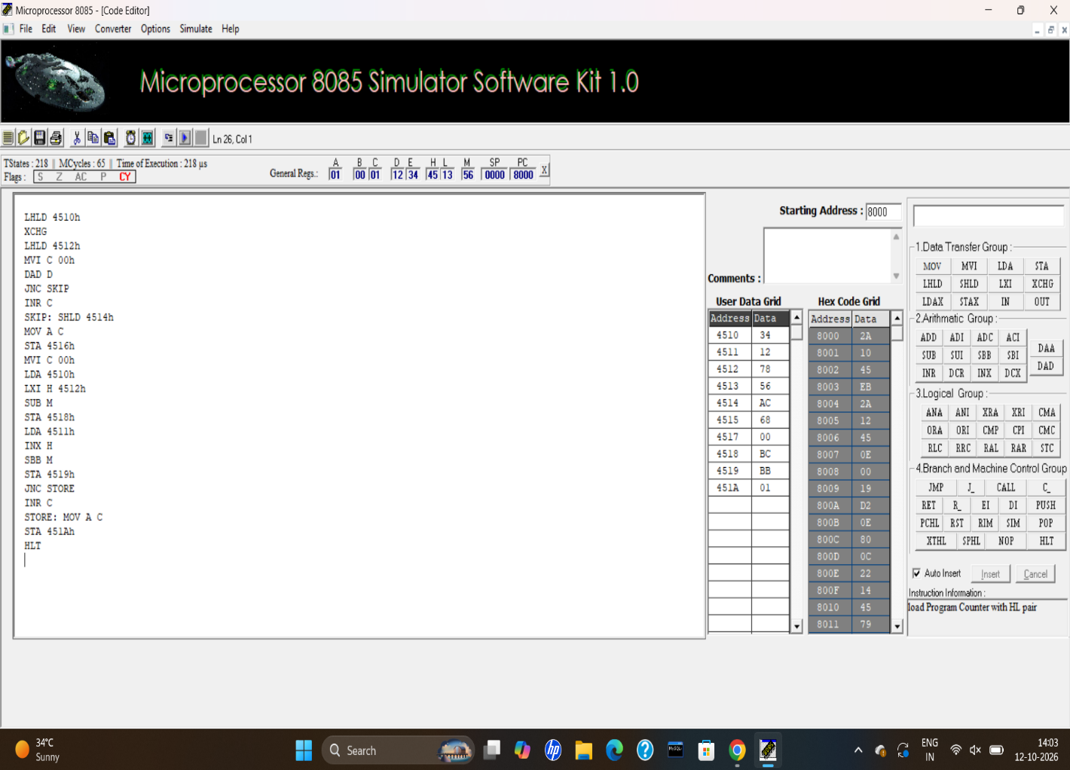

C. 8-Bit Multiplication and Division
Aim
To perform 8-bit multiplication using repeated addition. To perform 8-bit division using repeated subtraction and store the product, quotient and remainder.
Apparatus Required
- 8085 Microprocessor Simulator / Trainer Kit
- Keyboard
- Power Cord
Procedure
- Enter the program starting at memory address 4300.
- Store the multiplicand 12 at 4520 and multiplier 05 at 4521.
- Store the dividend 64 at 4524 and divisor 05 at 4525.
- Execute the program using the GO/EXEC command.
- Multiply the numbers using repeated addition and store the product at 4522 and 4523.
- Divide the dividend by repeatedly subtracting the divisor.
- Store the quotient at 4526 and remainder at 4527.
- Examine the memory locations and verify the results.
Pseudocode
START
Load multiplicand and multiplier
Clear product
Add multiplicand repeatedly
Store product
Load dividend and divisor
Clear quotient
Subtract divisor repeatedly
Increase quotient after each subtraction
Store quotient and remainder
STOP
Input
Address | Data
4520 | 12
4521 | 05
4524 | 64
4525 | 05
Output
Address | Output | Description
4522 | 5A | Product – lower byte
4523 | 00 | Product – upper byte
4526 | 14 | Quotient
4527 | 00 | Remainder
Result
The 8-bit multiplication and division operations were executed successfully. The product, quotient and remainder were verified.
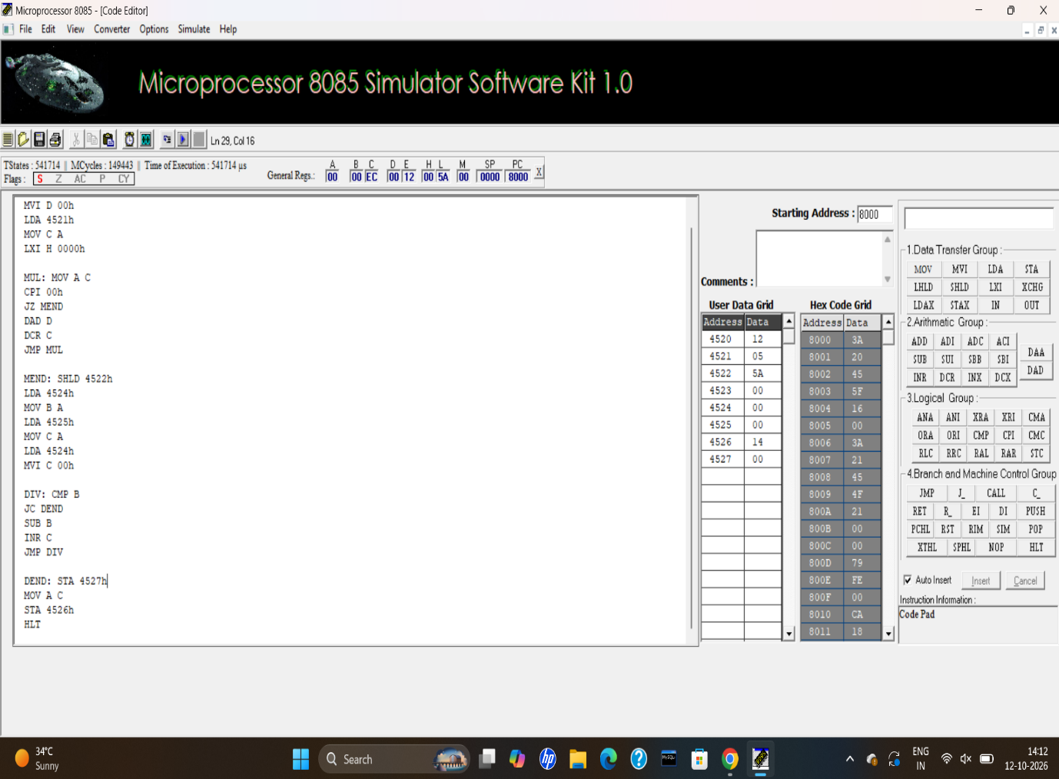

D. 16-Bit Multiplication and Division
Aim
To perform 16-bit multiplication using repeated addition. To perform 16-bit division using repeated subtraction and store the product, quotient and remainder.
Apparatus Required
- 8085 Microprocessor Simulator / Trainer Kit
- Keyboard
- Power Cord
Procedure
- Enter the program starting at memory address 4400.
- Store the first number 1234 from address 4530 and the second number 5678 from address 4532, with the lower byte first.
- Store the dividend 5678 from address 4538 and divisor 1234 from address 453A.
- Execute the program using the GO/EXEC command.
- Perform multiplication using repeated addition and store the 32-bit product at addresses 4534 to 4537.
- Perform division using repeated subtraction.
- Store the quotient at 453C and 453D.
- Store the remainder at 453E and 453F.
- Examine the memory locations and verify the results.
Pseudocode
START
Load the 16-bit numbers
Clear product
Add multiplicand repeatedly
Store the 32-bit product
Load dividend and divisor
Clear quotient
Subtract divisor repeatedly
Increase quotient after each subtraction
Store quotient and remainder
STOP
Input
Address | Data
4530 | 34
4531 | 12
4532 | 78
4533 | 56
4538 | 78
4539 | 56
453A | 34
453B | 12
Output
Address | Output | Description
4534 | 60 | Product – lowest byte
4535 | 00 | Product – second byte
4536 | 26 | Product – third byte
4537 | 06 | Product – highest byte
453C | 04 | Quotient – lower byte
453D | 00 | Quotient – upper byte
453E | A8 | Remainder – lower byte
453F | 0D | Remainder – upper byte
Result
The 16-bit multiplication and division operations were executed successfully.The product, quotient and remainder values were verified.

